**Vellore Institute of Technology**

**Principles of Operating Systems Lab (CBS1006)**

**Digital Assignment 2**

**Date**: 11 September 2022  
**Name**: Anuj Parihar  
**Registration Number**: 21BBS0162

**Question 1:** . Create a shell script programme that checks whether an input number is a palindrome.

**Code:**

echo "Registration Number: 21BBS0162"

echo "Name: Anuj Parihar"

echo "Enter a number: "

read num

temp=$num

rev=0

while [ $num -gt 0 ]

do

a=`expr $num % 10`

num=`expr $num / 10`

rev=`expr $rev \* 10 + $a`

done

if [ $temp -eq $rev ]

then

echo "Number is palindrome"

else

echo "Number is not palindrome"

fi

**Screenshot:**

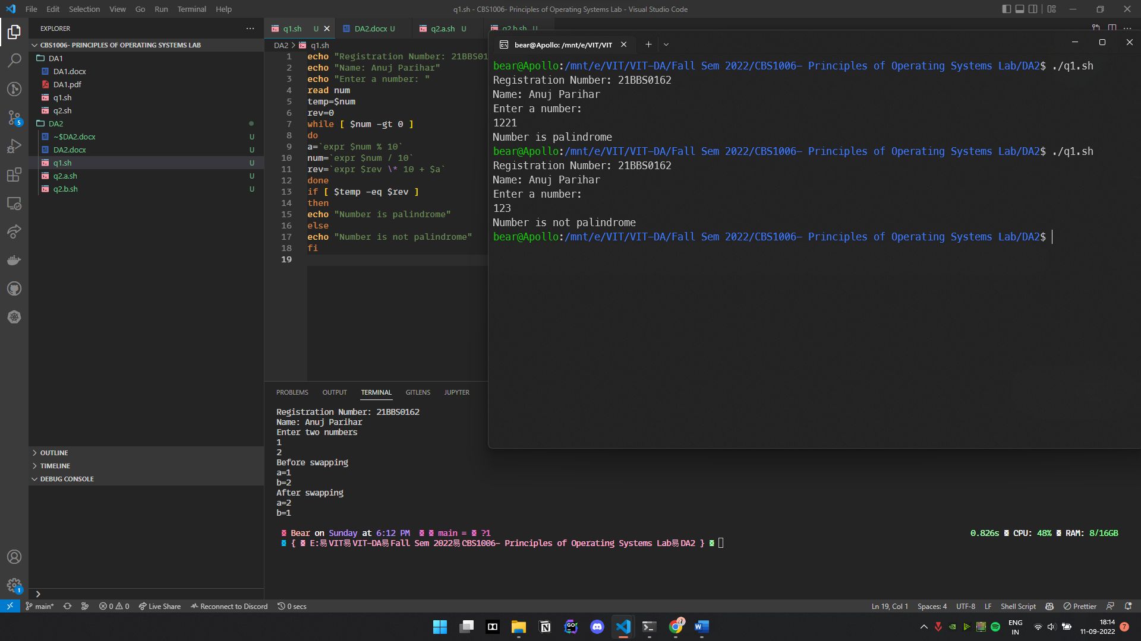

**Question 2 a:** Write a shell script program to swap two numbers with third variable.

**Code:**

echo "Registration Number: 21BBS0162"

echo "Name: Anuj Parihar"

echo "Enter two numbers"

read a

read b

echo "Before swapping"

echo "a=$a"

echo "b=$b"

temp=$a

a=$b

b=$temp

echo "After swapping"

echo "a=$a"

echo "b=$b"

**Screenshot:**

**Question 2 b:** Write a shell script program to swap two numbers without third variable.

**Code:**

echo "Registration Number: 21BBS0162"

echo "Name: Anuj Parihar"

echo "Enter two numbers"

read a

read b

echo "Before swapping"

echo "a=$a"

echo "b=$b"

a=`expr $a + $b`

b=`expr $a - $b`

a=`expr $a - $b`

echo "After swapping"

echo "a=$a"

echo "b=$b"

**Screenshot:**

